**Results**

**System Landing page:** The main page displays two options for the users. Existing customers, tellers or administrators need to select option ‘1’ and new sign‑up customers need to select option ‘2’ for creating new account.

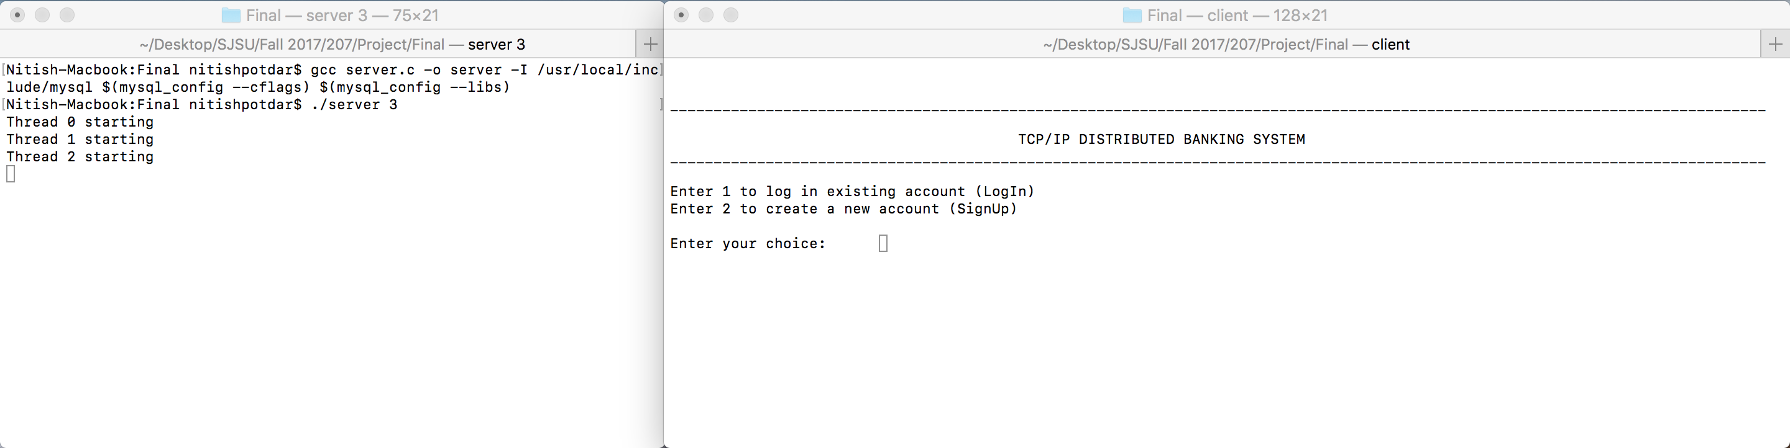

Fig. 1.1 – System landing page

**New customer sign‑up:** To create new account, the customers are requested for details such as email address, password, full name, phone number and address. The login ID is auto‑generated by the system for the customer and sent through an email communication. Fig 1.2 shows the system requesting details to customer for new account sign‑up.

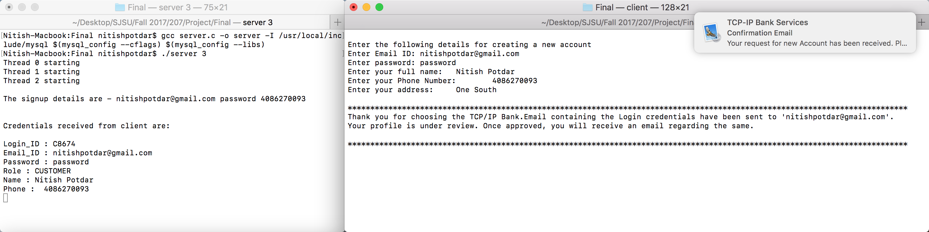

Fig 1.2 – New customer sign‑up

An email is sent to the customer from the bank email address informing the customer for successful account creation and consisting of the login ID for the customer for logging into the system once a teller approves it.

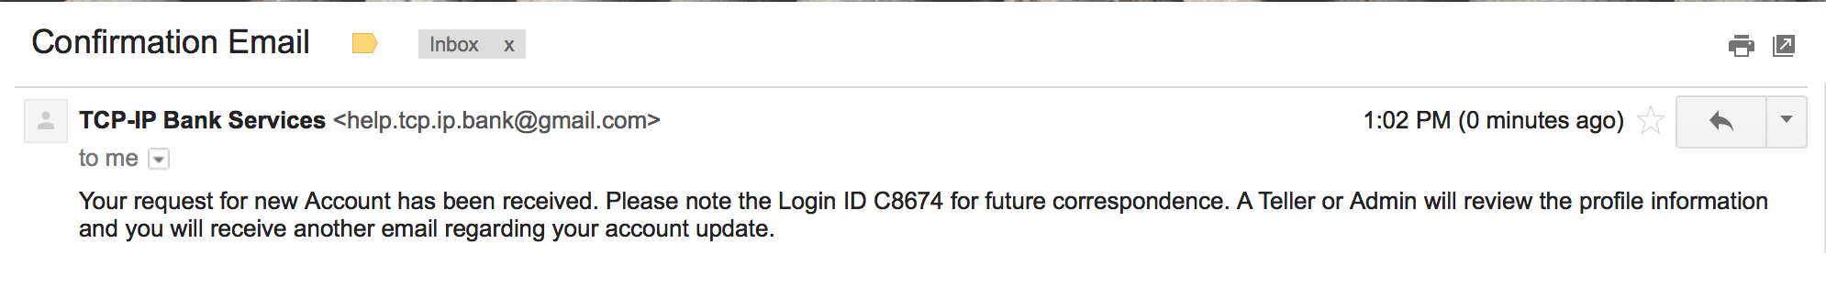

Fig 1.3 – New customer sign‑up mail

The details of new account created for the customer are inserted into a ‘validate_login’ table as shown in Fig. 1.4. When a teller logs into the system and approves the pending customer account validation as shown in Fig. 1.5, the details of customer account are inserted into the ‘login’ table as shown in Fig. 1.6 and an email communication is sent to the customer indicating that the account has been approved by a teller as shown in Fig. 1.7.

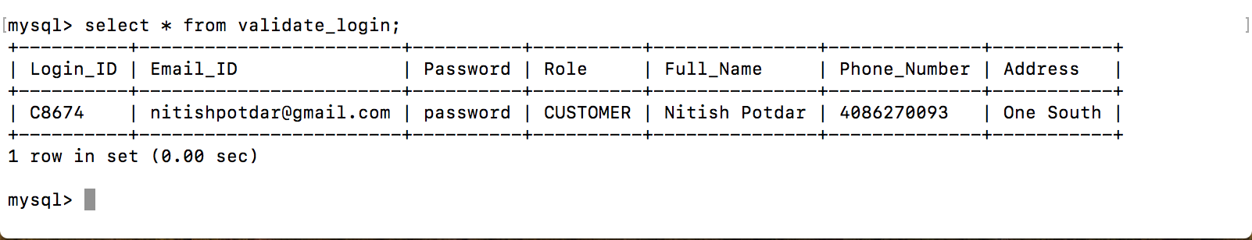

Fig 1.4 – New customer details inserted into ‘validate_login’ table

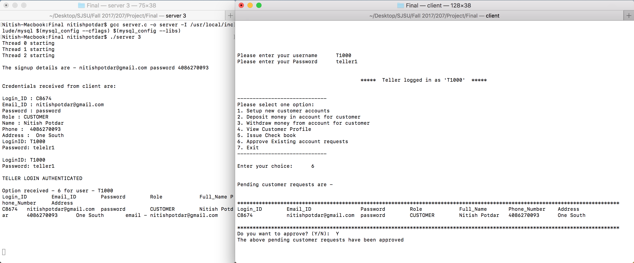

Fig 1.5 – Pending customer accounts approved by teller

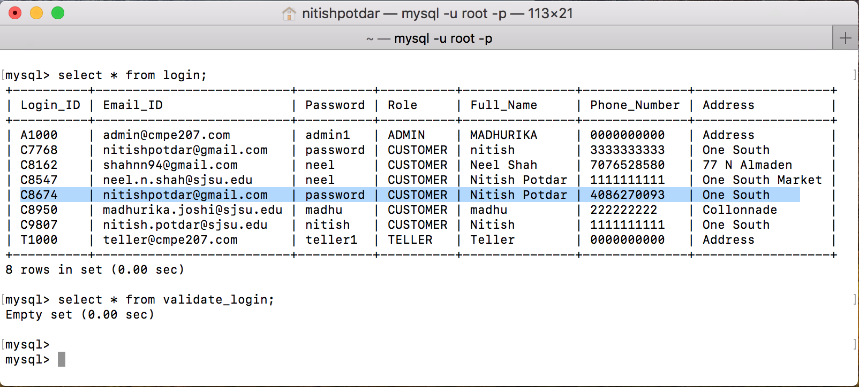

Fig 1.6 – Account details inserted into ‘login’ table after teller approval

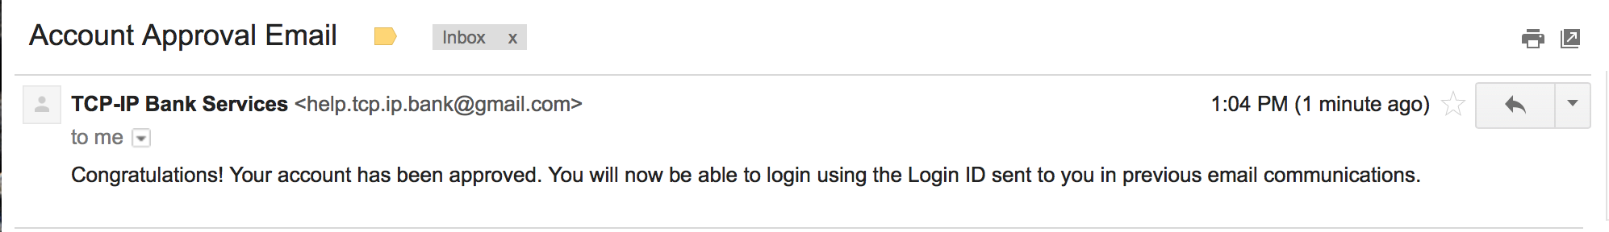

Fig 1.7 – Account approval email sent to the customer

**Existing user login:** Existing customers, tellers and administrators can login into the system by selecting option ‘1’ on the main landing page of the system. Upon successful login, customers, teller and administrators will be provided with role specific options.

Fig. 1.8, 1.9, 1.10 below show the customer, teller and administrator options respectively.

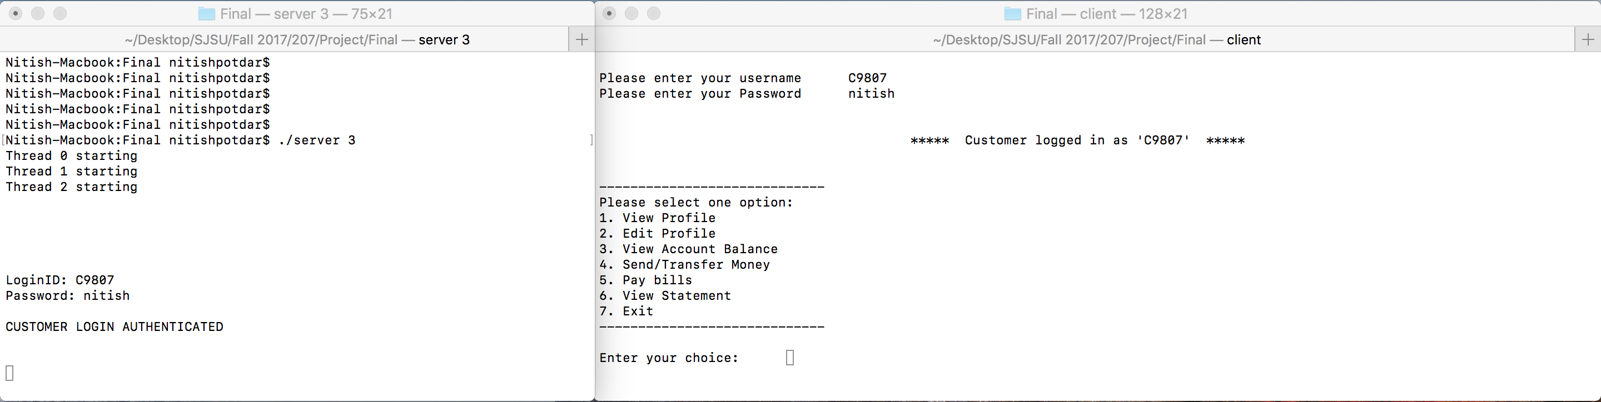

Fig 1.8 – Customer options

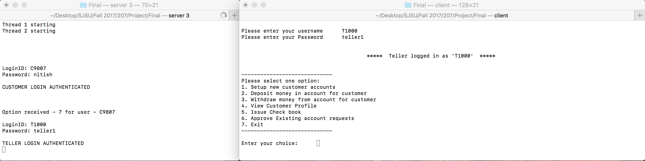

Fig 1.9 – Teller options

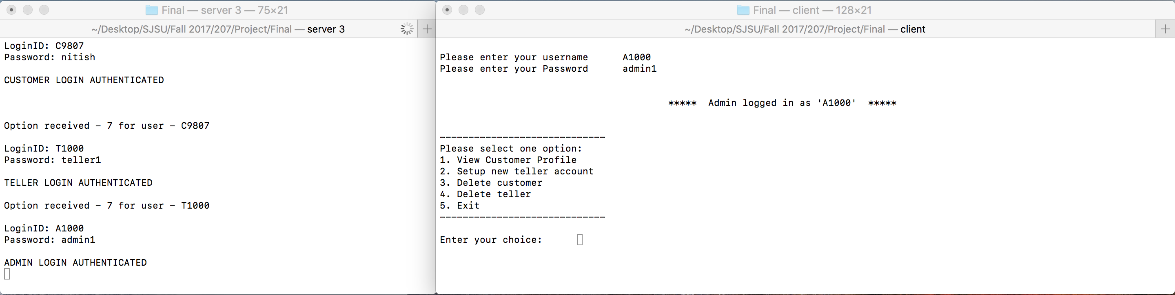

Fig 1.10 – Administrator options

The various customer options are as listed below:

1. Option 1 – View profile

Fig. 1.11 show the view profile option where customer details are fetched from ‘login’ table and displayed to the customer.

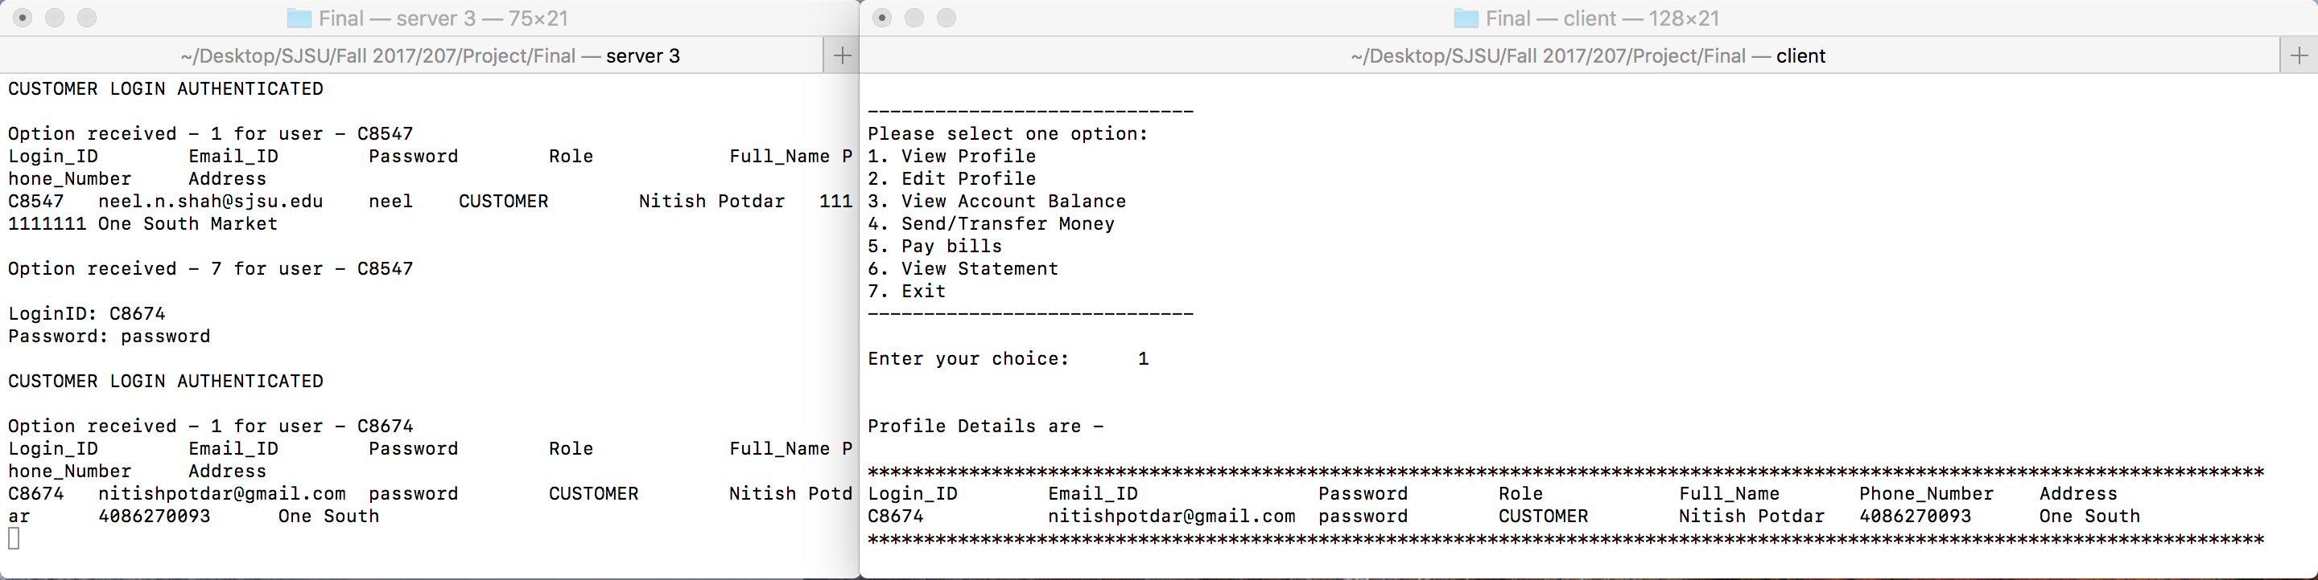

Fig 1.11 – View profile option for customer

1. Option 2 – Edit profile

Fig 1.12 show the edit profile option where the customer can edit either the email address, password, phone number or address.

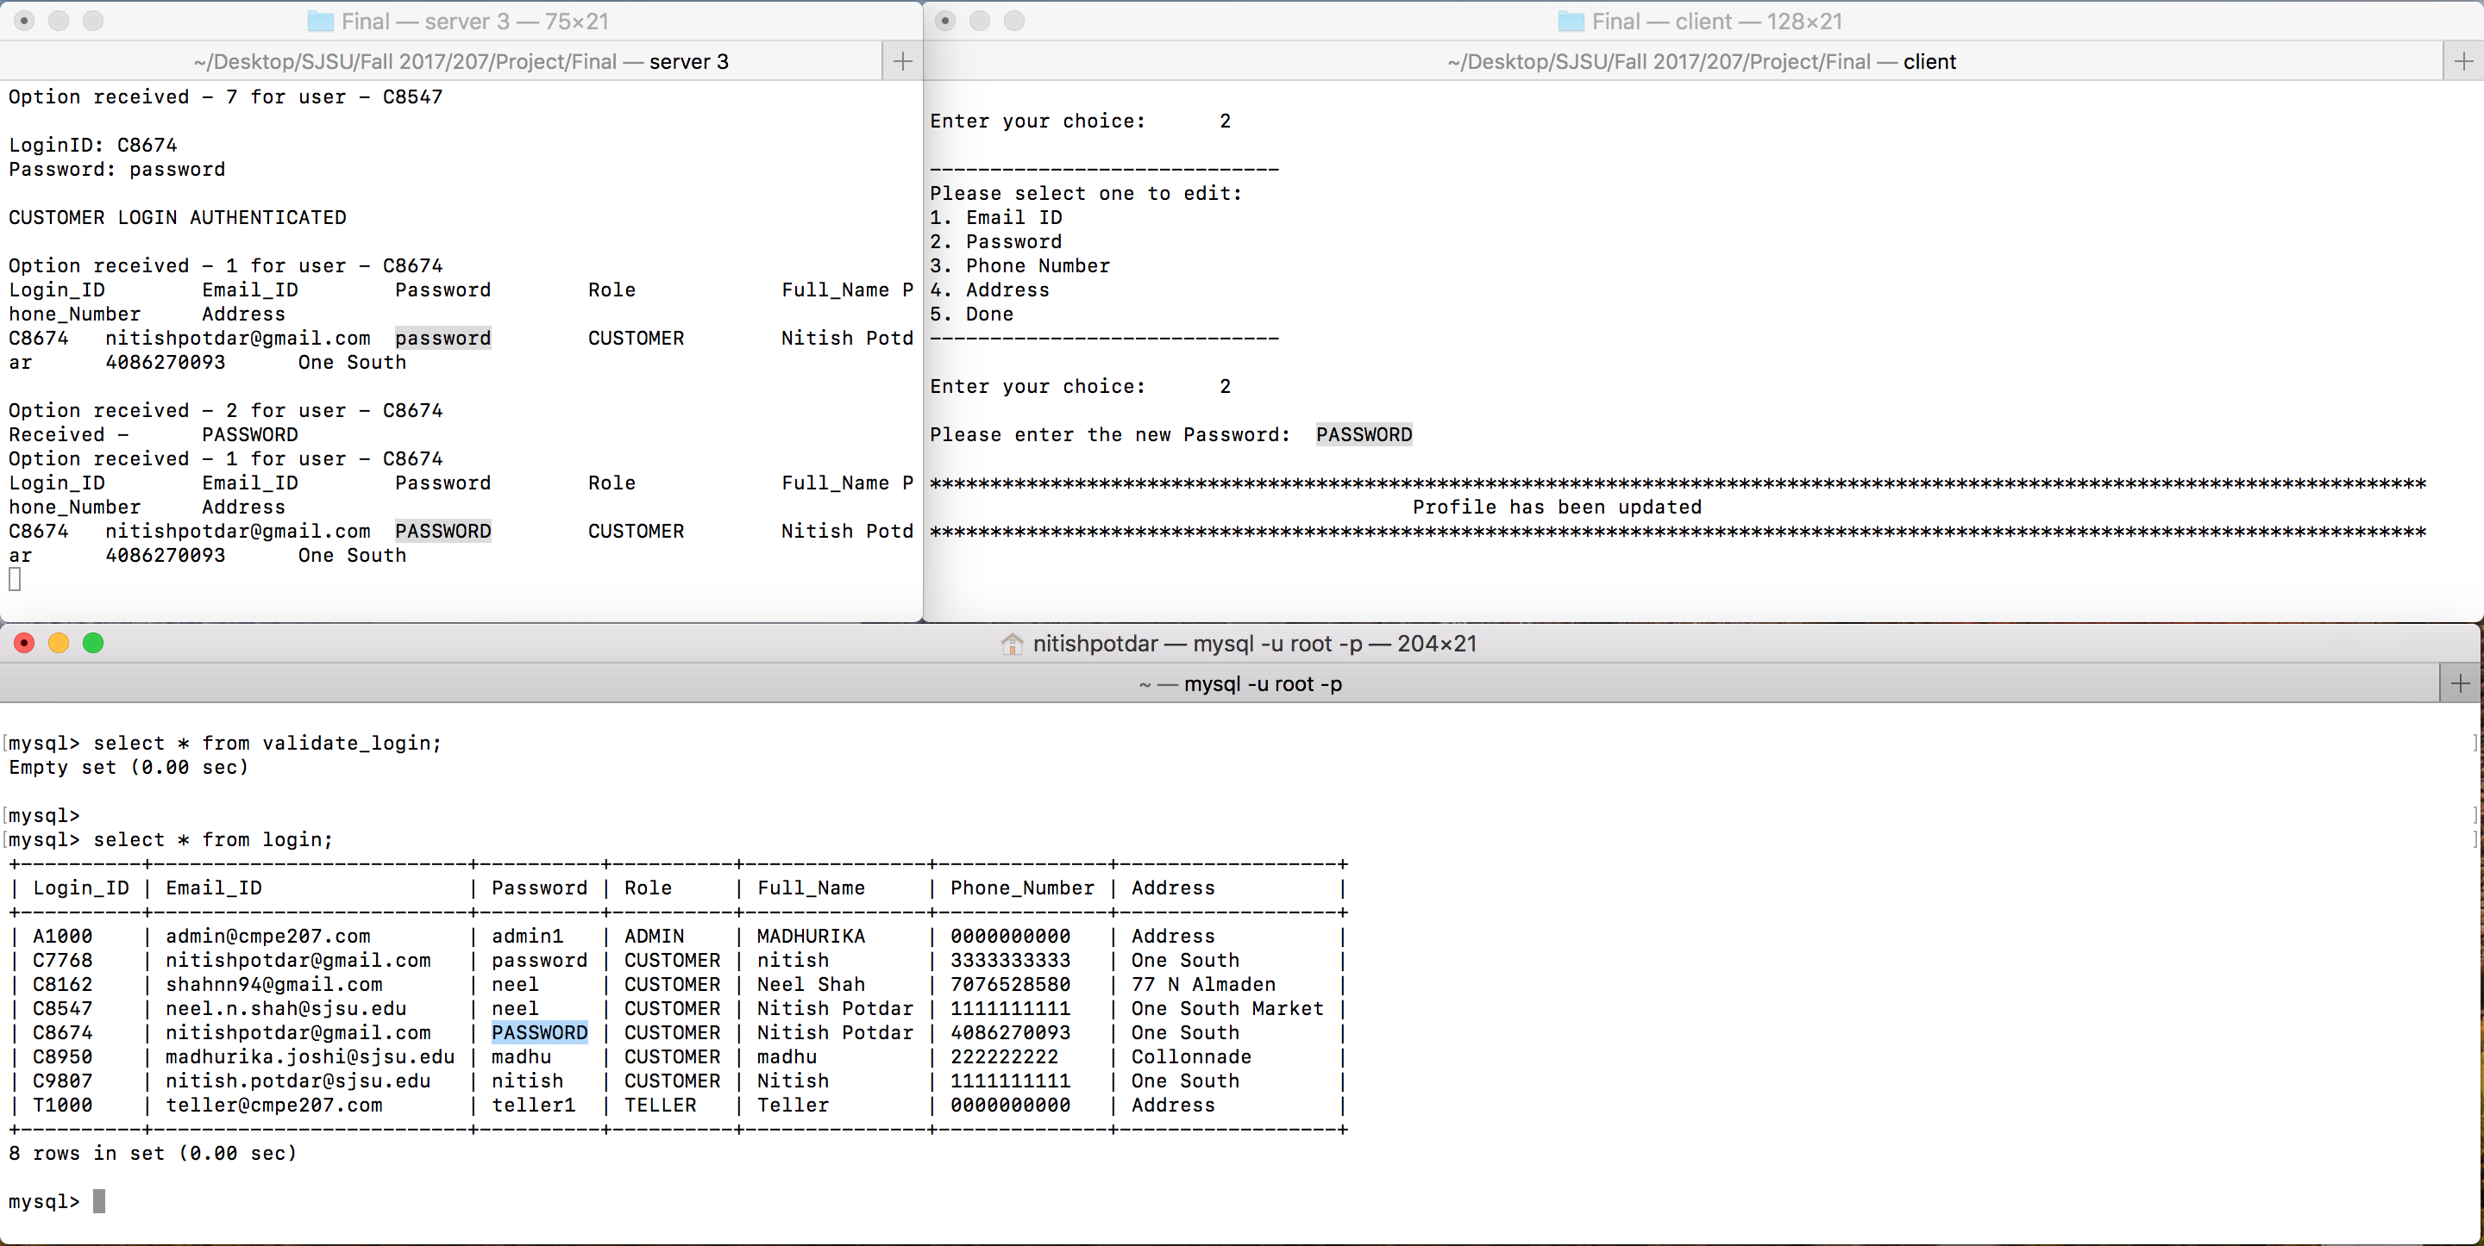

Fig 1.12 – Edit profile option for customer

1. Option 3 – View account balance

Fig. 1.13 shows the view account balance option for the customer.

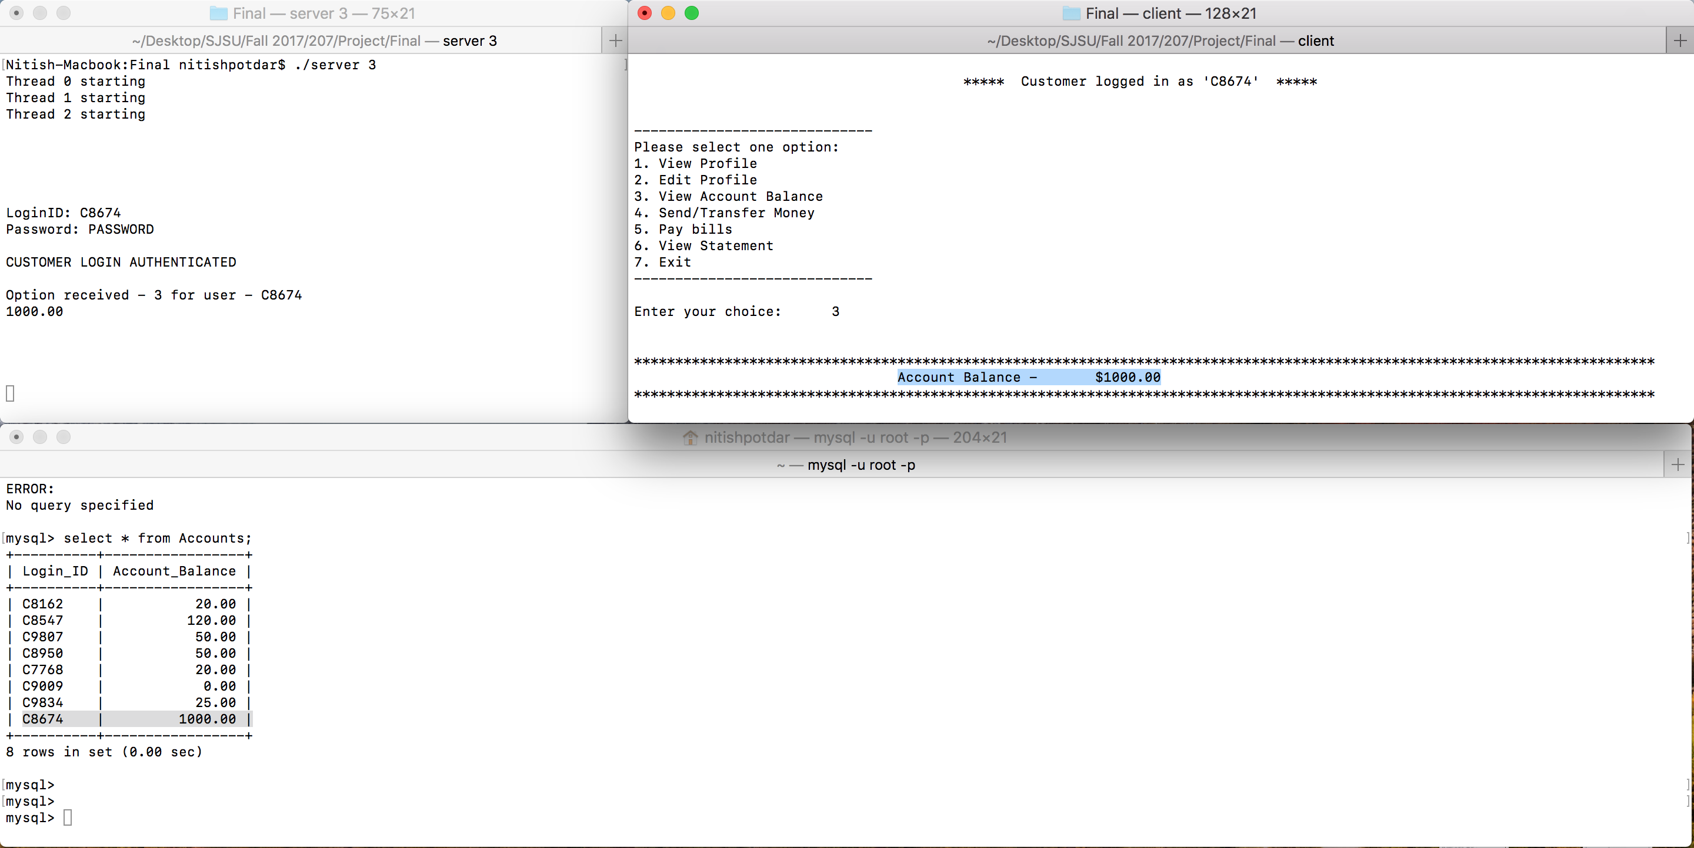

Fig 1.13 – View account balance option for customer

1. Option 4 – Send/Transfer money

Fig. 1.14 shows a successful transfer of money from one customer’s account to another. Fig. 1.15 shows an unsuccessful transfer of money due to insufficient balance in the account. Fig. 1.16 shows an unsuccessful transfer of money due to invalid customer ID.

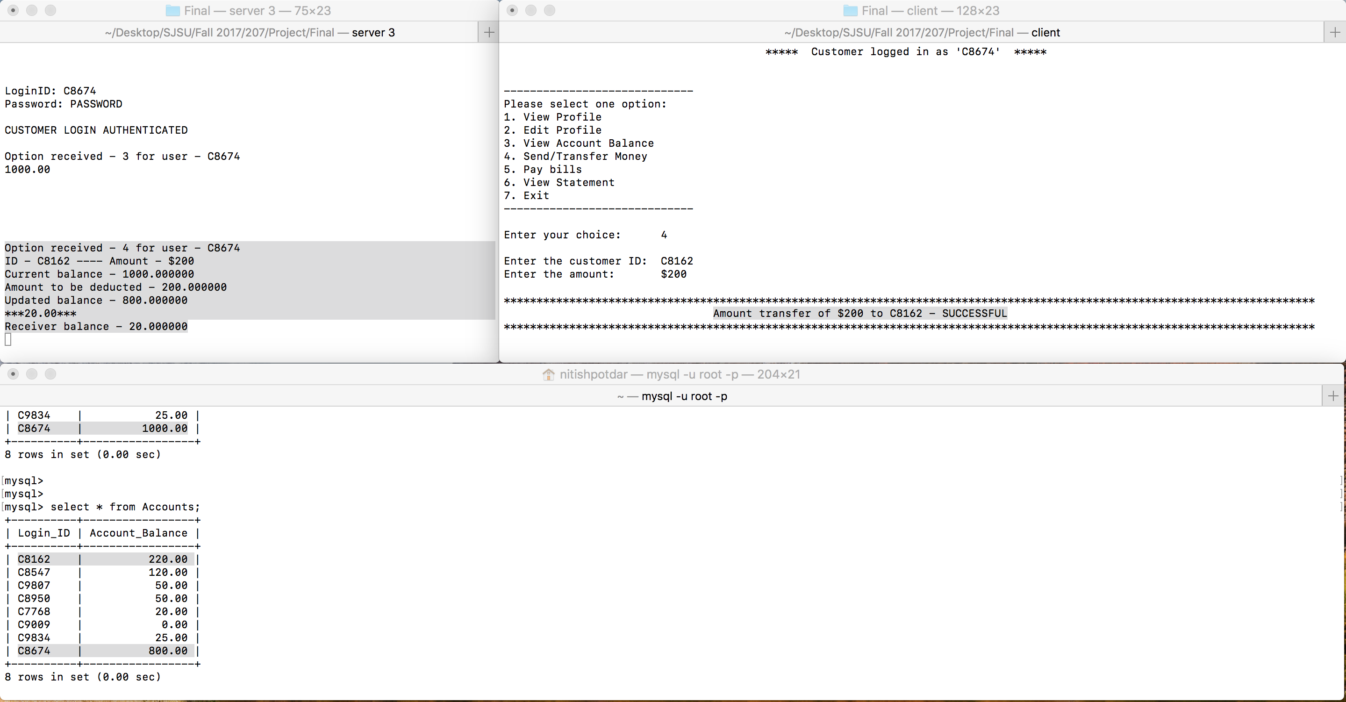

Fig 1.14 – Send money option for customer (Success)

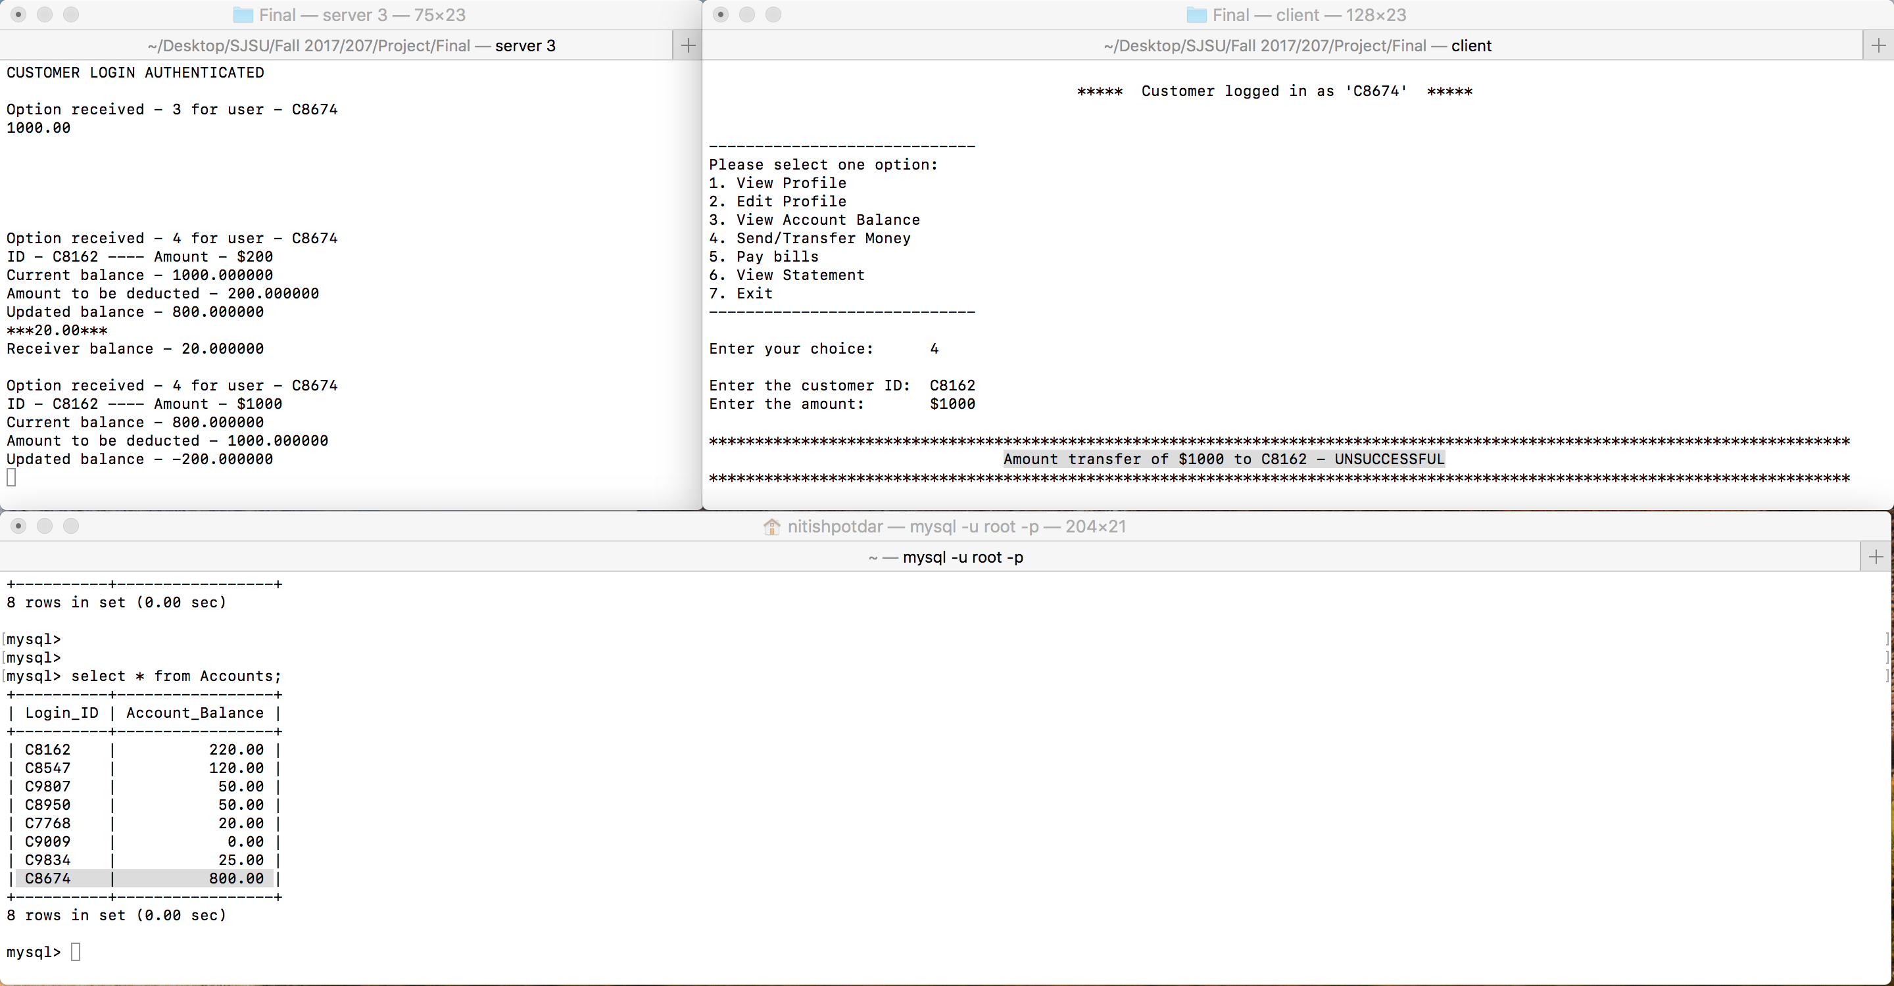

Fig 1.15 – Send money option for customer (Unsuccessful due to low balance)

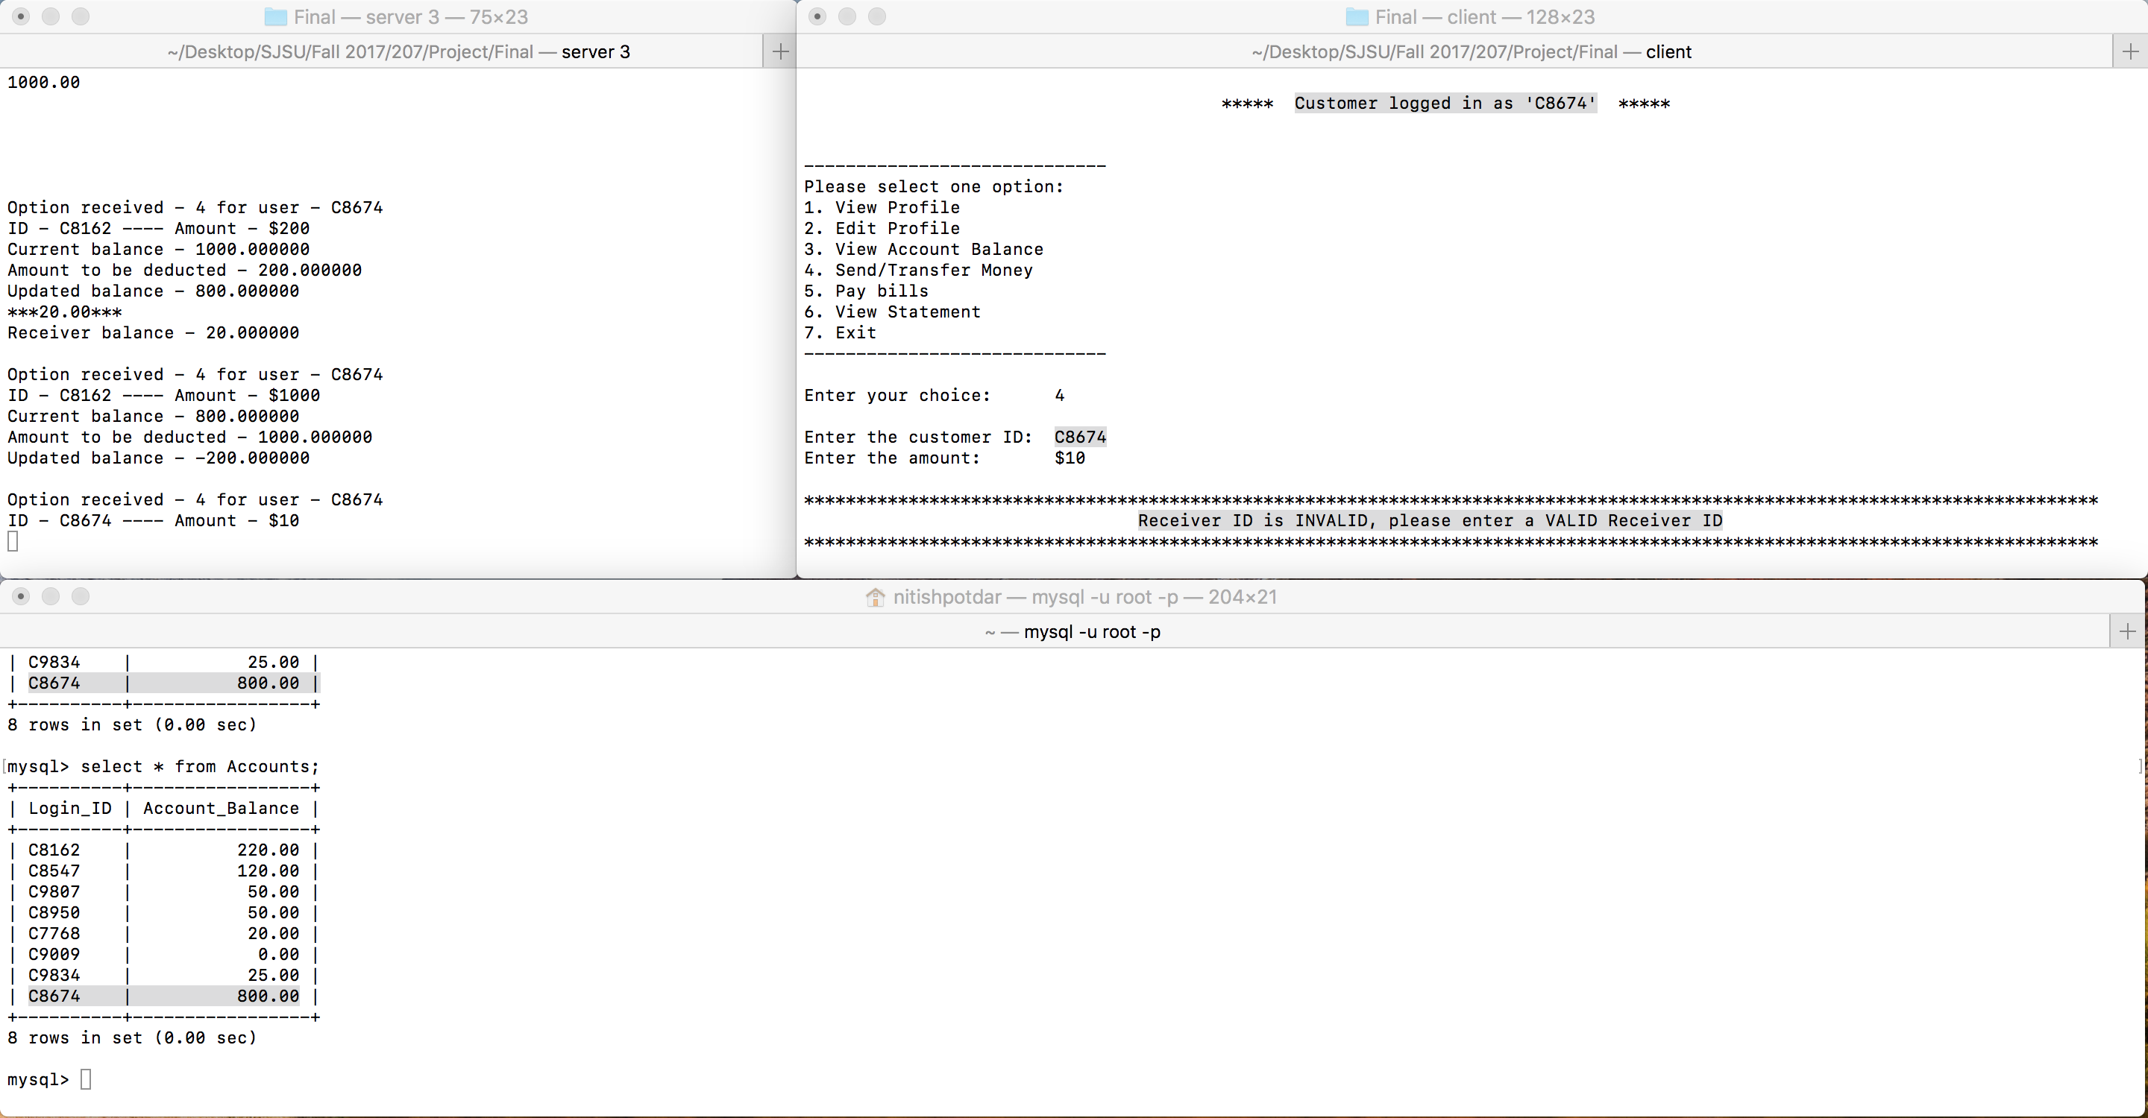

Fig 1.16 – Send money option for customer (Unsuccessful due to invalid customer ID)

1. Option 5 – Pay bills

Fig. 1.17 shows the pay bills option for the customer where he/she can select the payee, the account number and the amount to be paid.

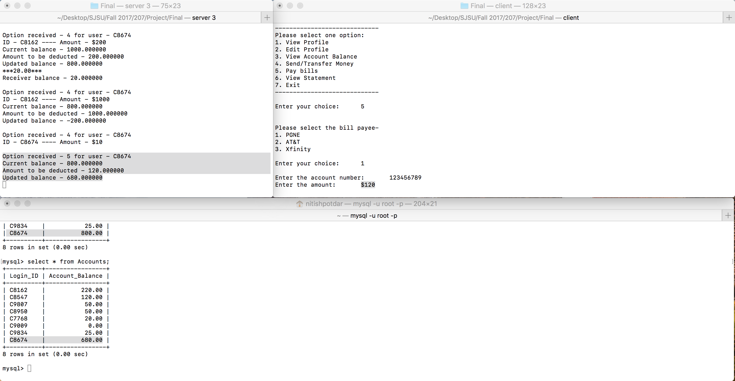

Fig 1.17 – Pay bills option for customer

1. Option 6 – View statement

Fig. 1.18 shows the view statement option for the customer where all the sent and received transactions are displayed.

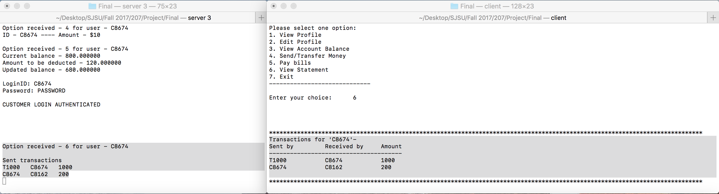

Fig 1.18 – View statement option for customer

The various teller options are as listed below:

1. Option 1 – Setup new customer accounts

Fig. 1.19 shows a customer account creation by teller. When a customer account is created by a teller, the account doesn’t need approval and the customer details are directly entered into the ‘login’ table. An email communication is also sent to the customer as shown in Fig. 1.20.

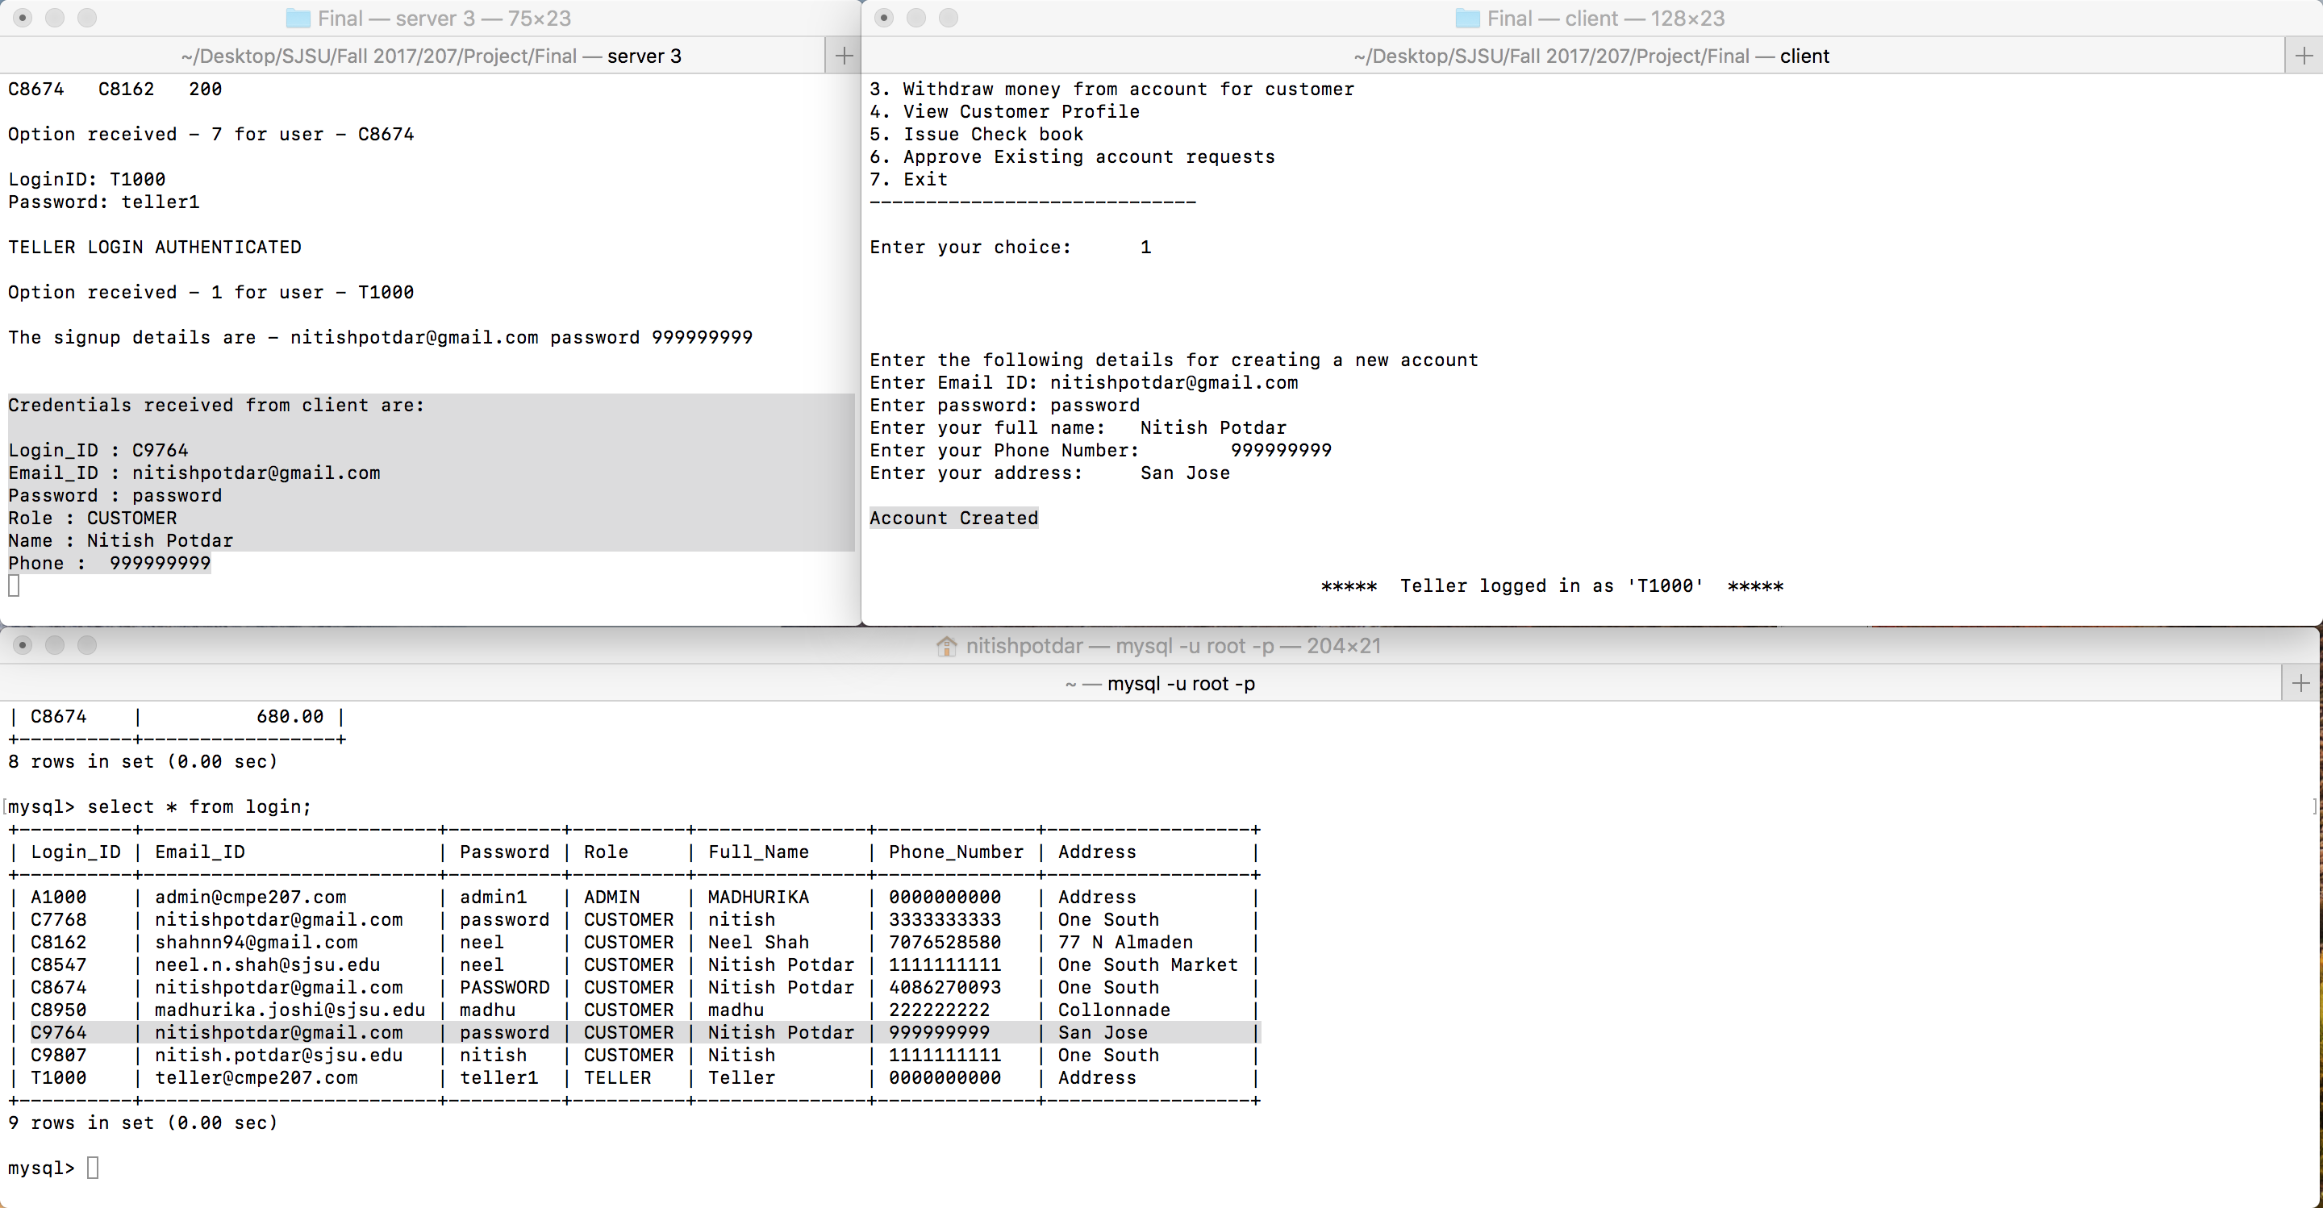

Fig 1.19 – Setup new customer account option for teller

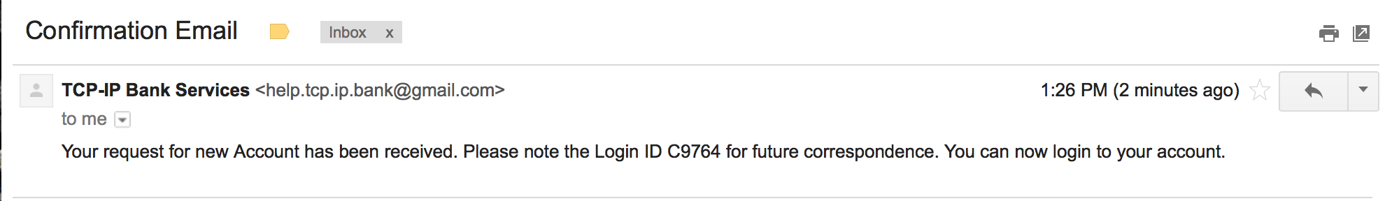

Fig 1.20 – Email communication sent to customer upon account creation

1. Option 2 – Deposit money in account for customer

Fig. 1.21 shows the deposit money option for a customer to the teller. The system requests the teller for a customer ID and the amount to be deposited into the customer’s account.

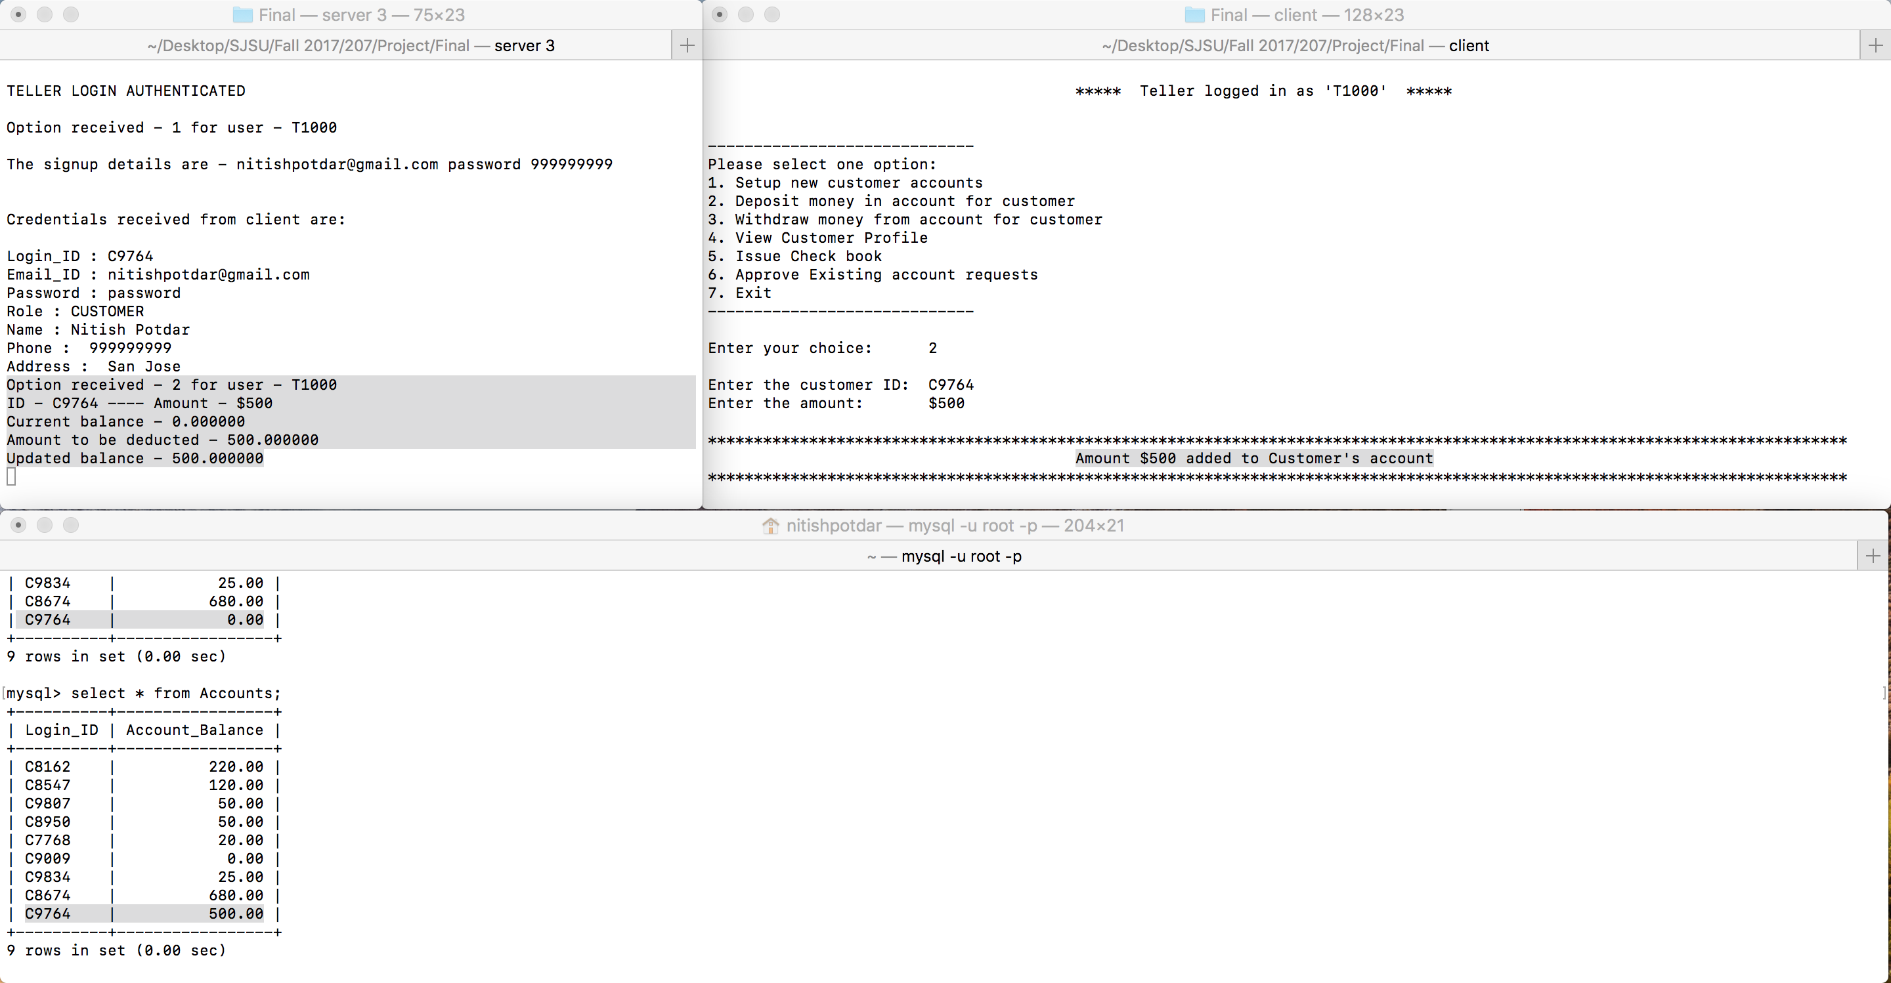

Fig 1.21 – Deposit money in customer account option for teller

1. Option 3 – Withdraw money from account for customer

Fig. 1.22 shows the withdraw money option for a customer to the teller. The system requests the teller for a customer ID and the amount to be withdrawn from the customer’s account.

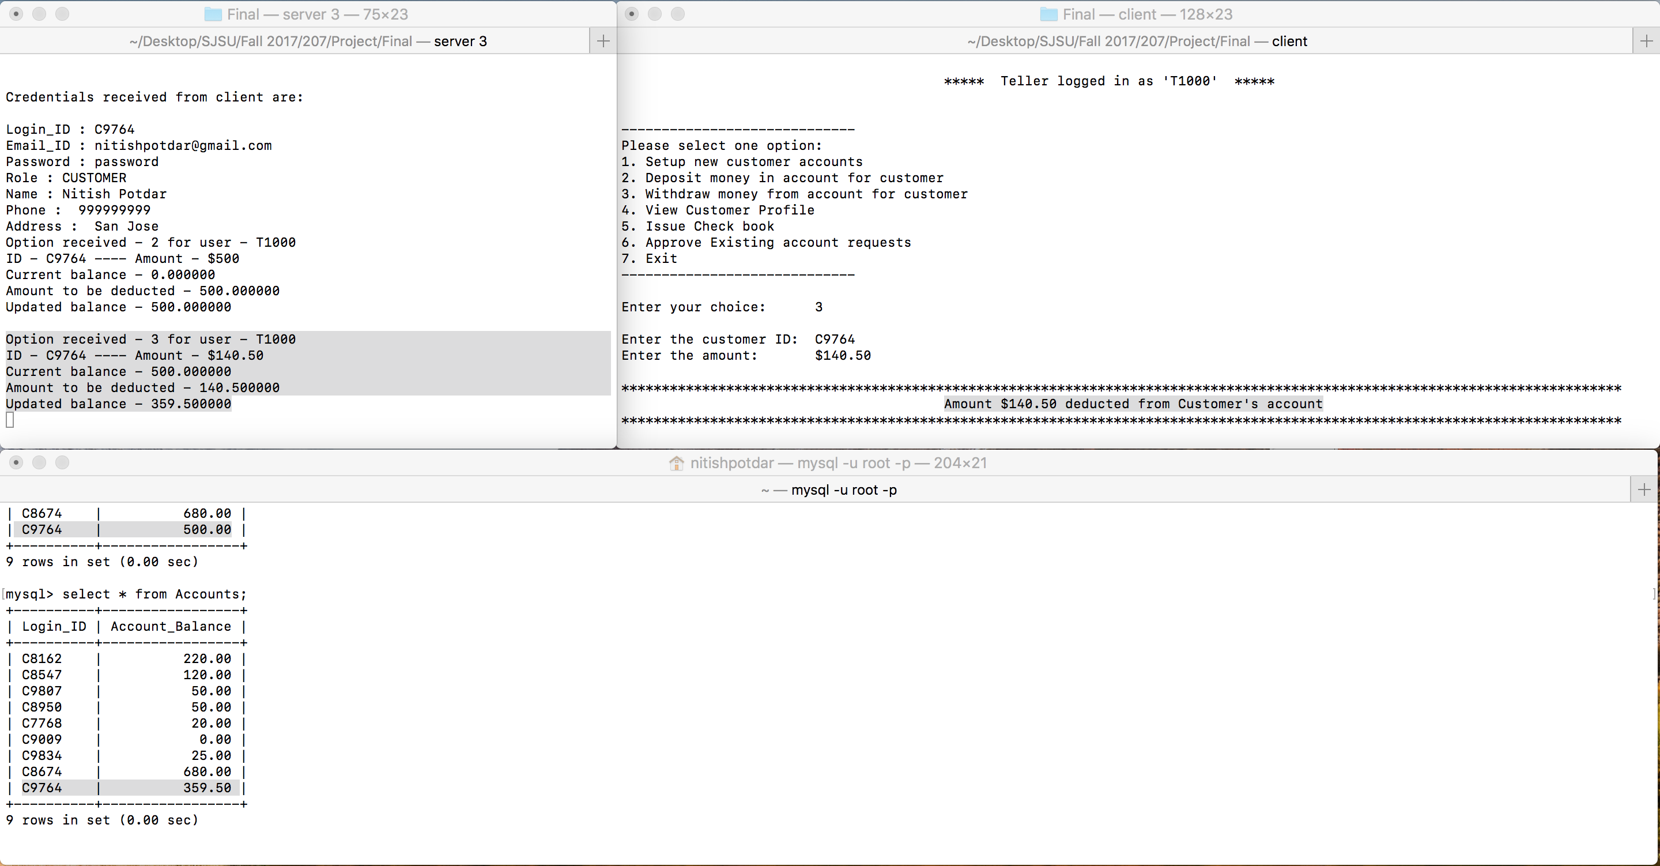

Fig 1.22 – Withdraw money from customer account option for teller

1. Option 4 – View customer profile

Fig. 1.23 shows the view customer profile option where the teller needs to enter a customer ID and the customer details are fetched from ‘login’ table and displayed to the teller.

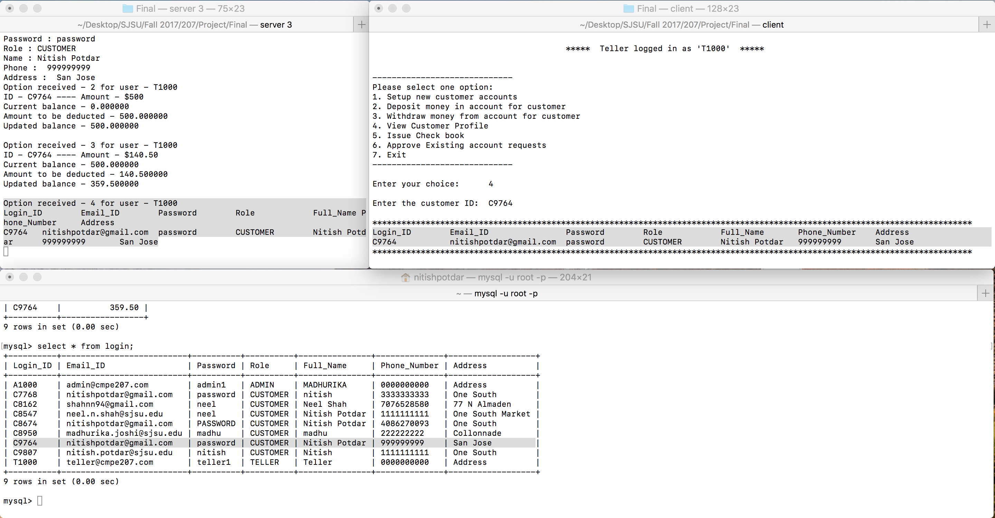

Fig 1.23 – View customer profile option for teller

1. Option 5 – Issue check book

Fig. 1.24 shows issue check book option for teller. The system requests for a customer ID to the teller and an email communication is sent to the customer on successful request completion as shown in fig. 1.25.

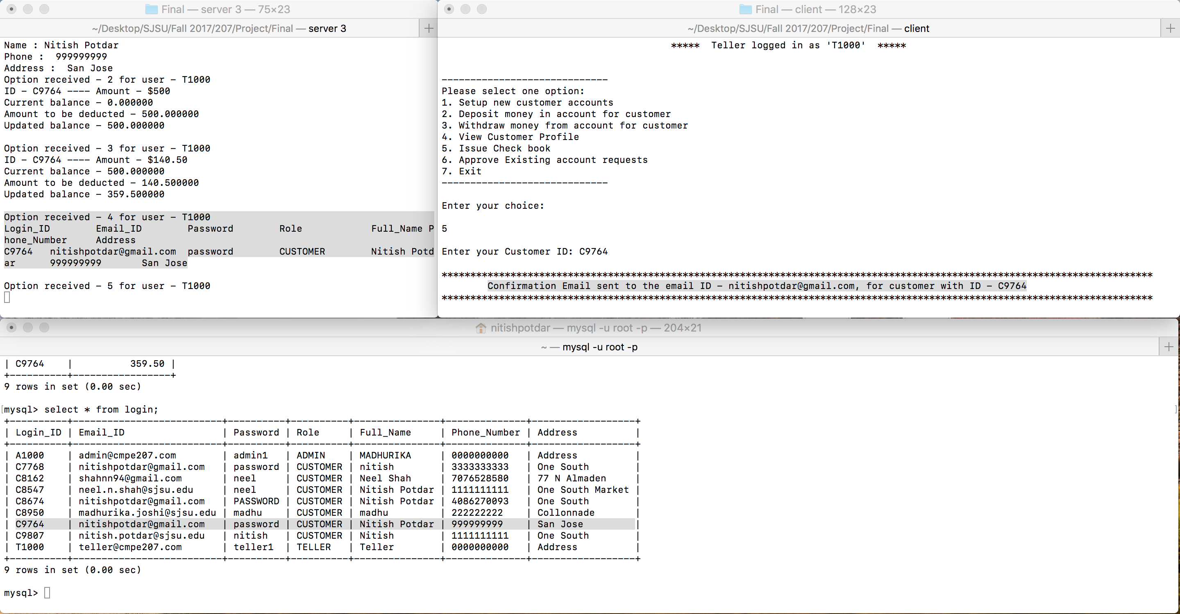

Fig 1.24 – Issue check book option for teller

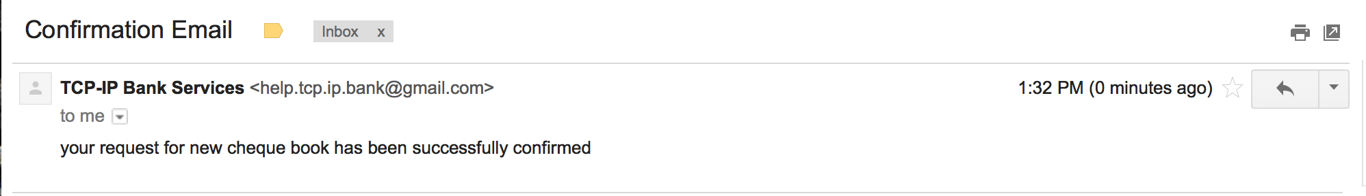

Fig 1.25 – Check book request success mail sent to the customer

1. Option 6 – Approve pending customer requests

Fig. 1.26 shows the approve pending customer requests option for teller where the teller can approve all pending customer requests.



Fig 1.26 – Approve pending customer requests option for teller

The various administrator options are as listed below:

1. Option 1 – View customer profile

Fig. 1.27 shows the view customer profile option where the admin needs to enter a customer ID and the customer details are fetched from ‘login’ table and displayed to the admin.

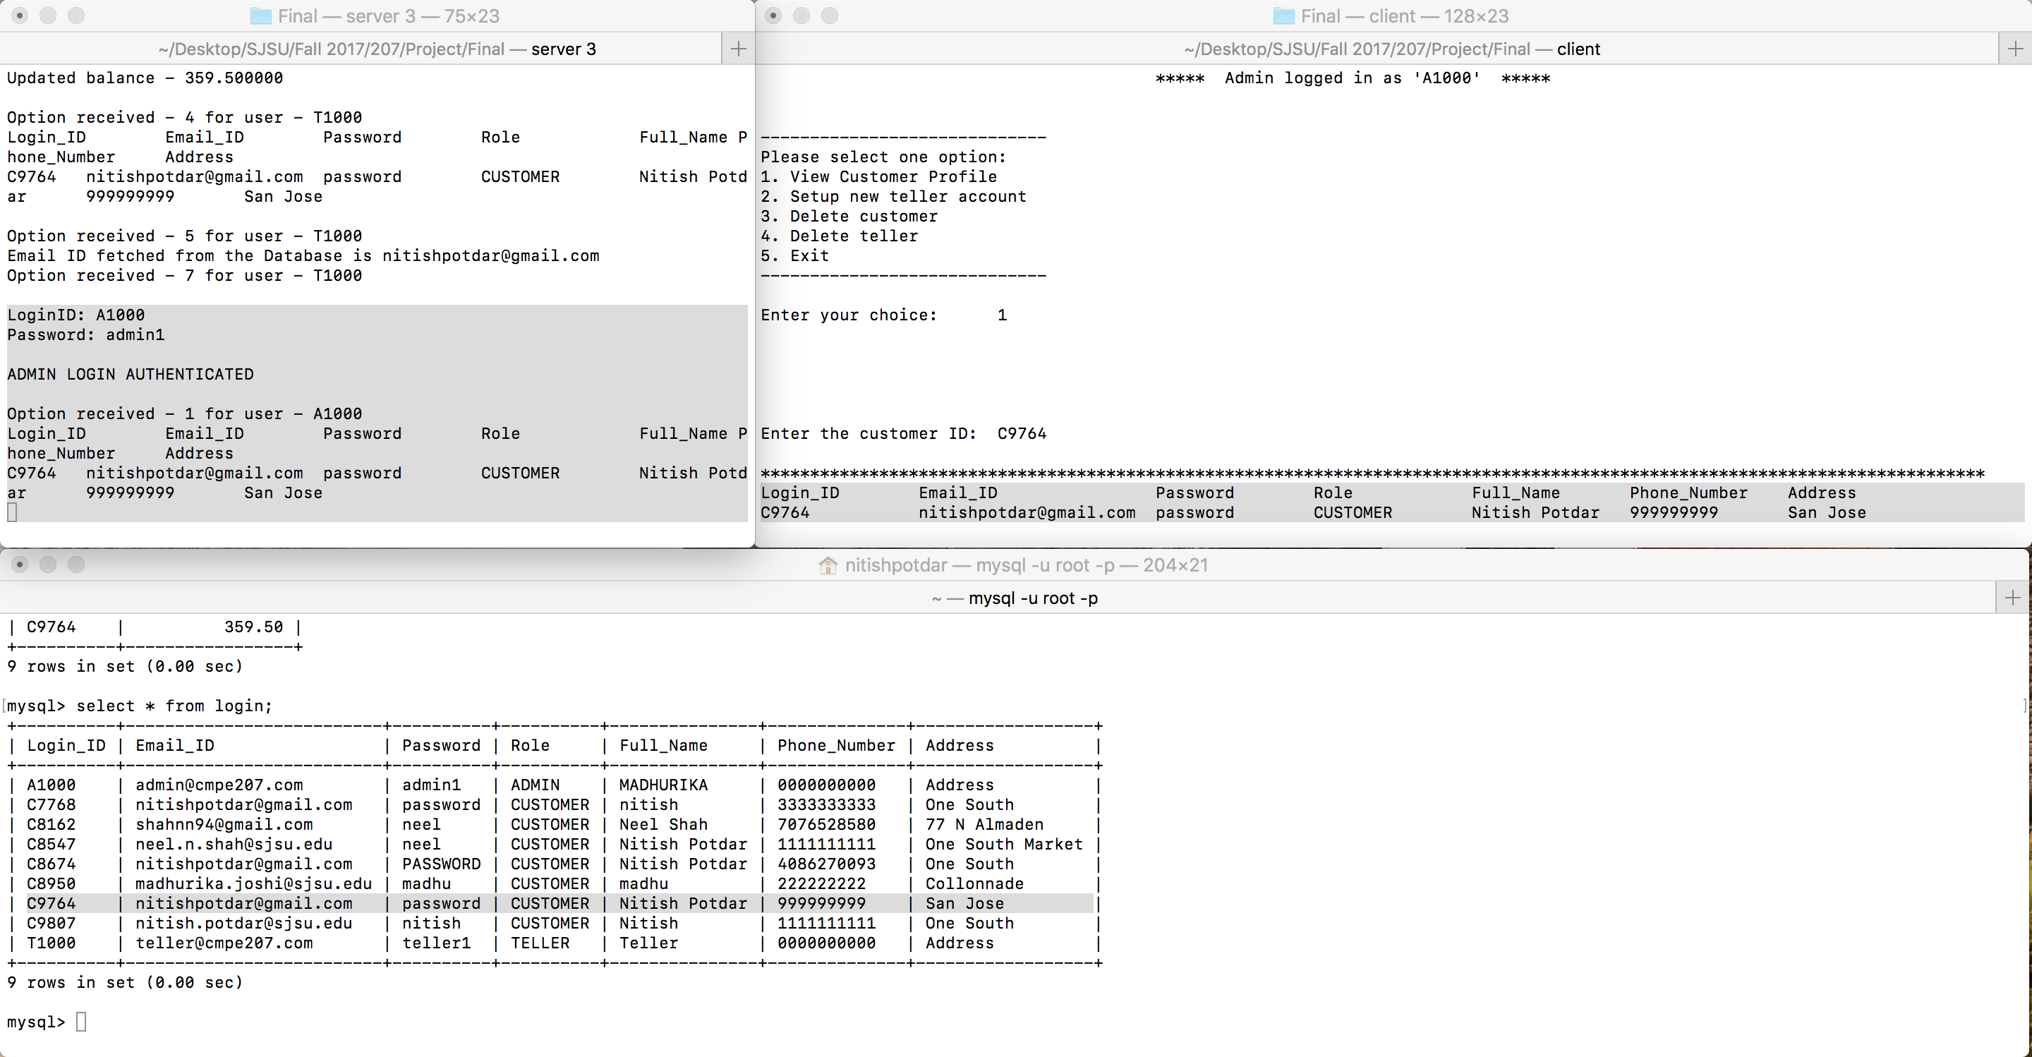

Fig 1.27 – View customer profile option for admin

1. Option 2 – Setup new teller accounts

Fig. 1.28 shows a teller account creation by admin. When a teller account is created by a admin, the account doesn’t need approval and the teller details are directly entered into the ‘login’ table.

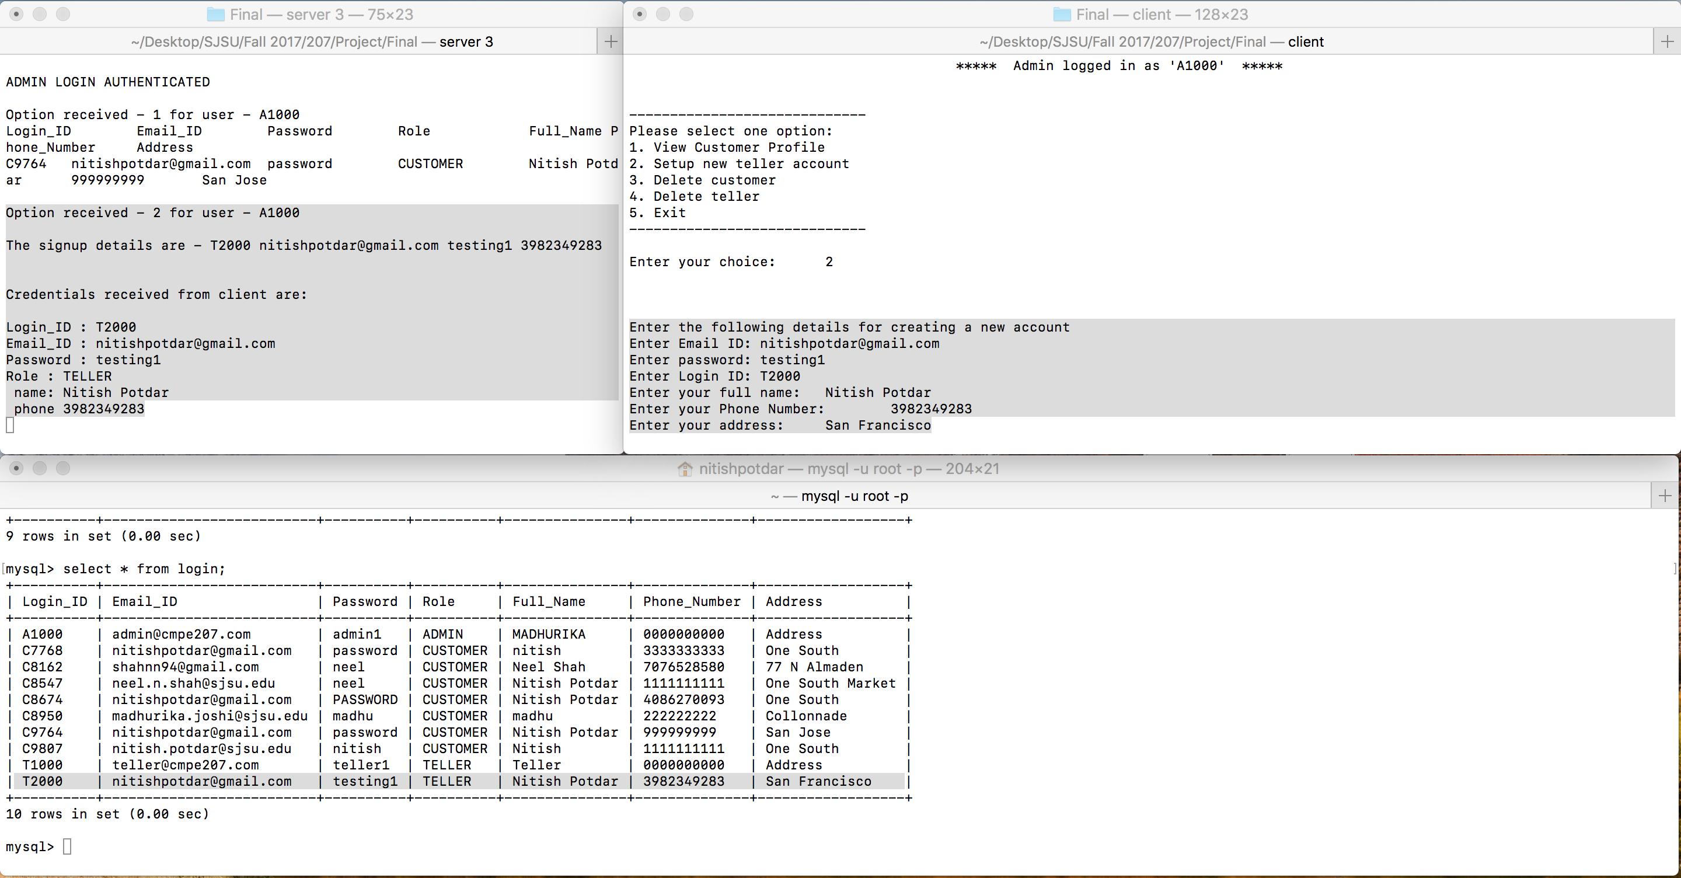

Fig 1.27 – Setup new teller accounts option for admin

1. Option 3 – Delete customer

Fig. 1.28 shows the delete customer option for admin. The system requests a customer ID to the admin whose account needs to be deleted from the system.

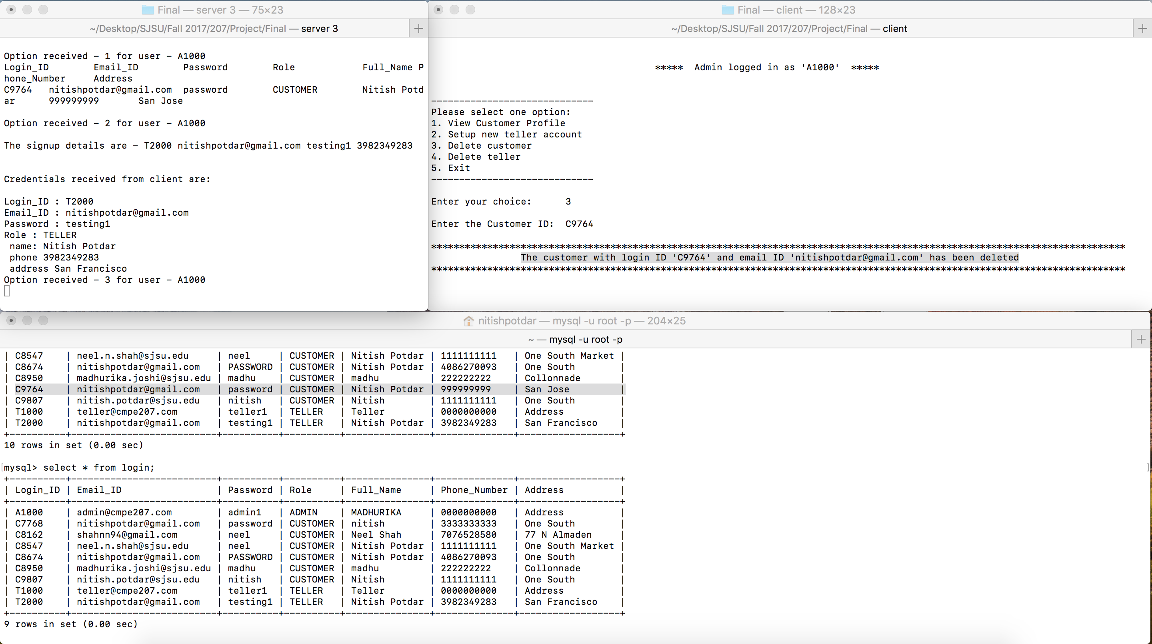

Fig 1.28 – Delete customer option for admin

1. Option 4 – Delete teller

Fig. 1.29 shows the delete teller option for admin. The system requests a teller ID to the admin whose account needs to be deleted from the system.

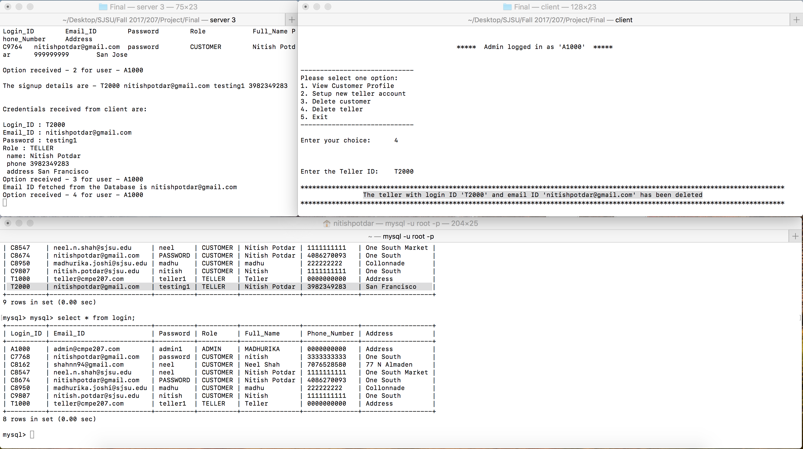

Fig 1.29 – Delete teller option for admin

Server Concurrency: We have provided server concurrency by implementing a pre‑threaded multi‑threading server which create number of threads as specified on command line on server side prior to any client requests. Thus, the server can handle and process multiple client requests simultaneously as shown in Fig. 1.30.

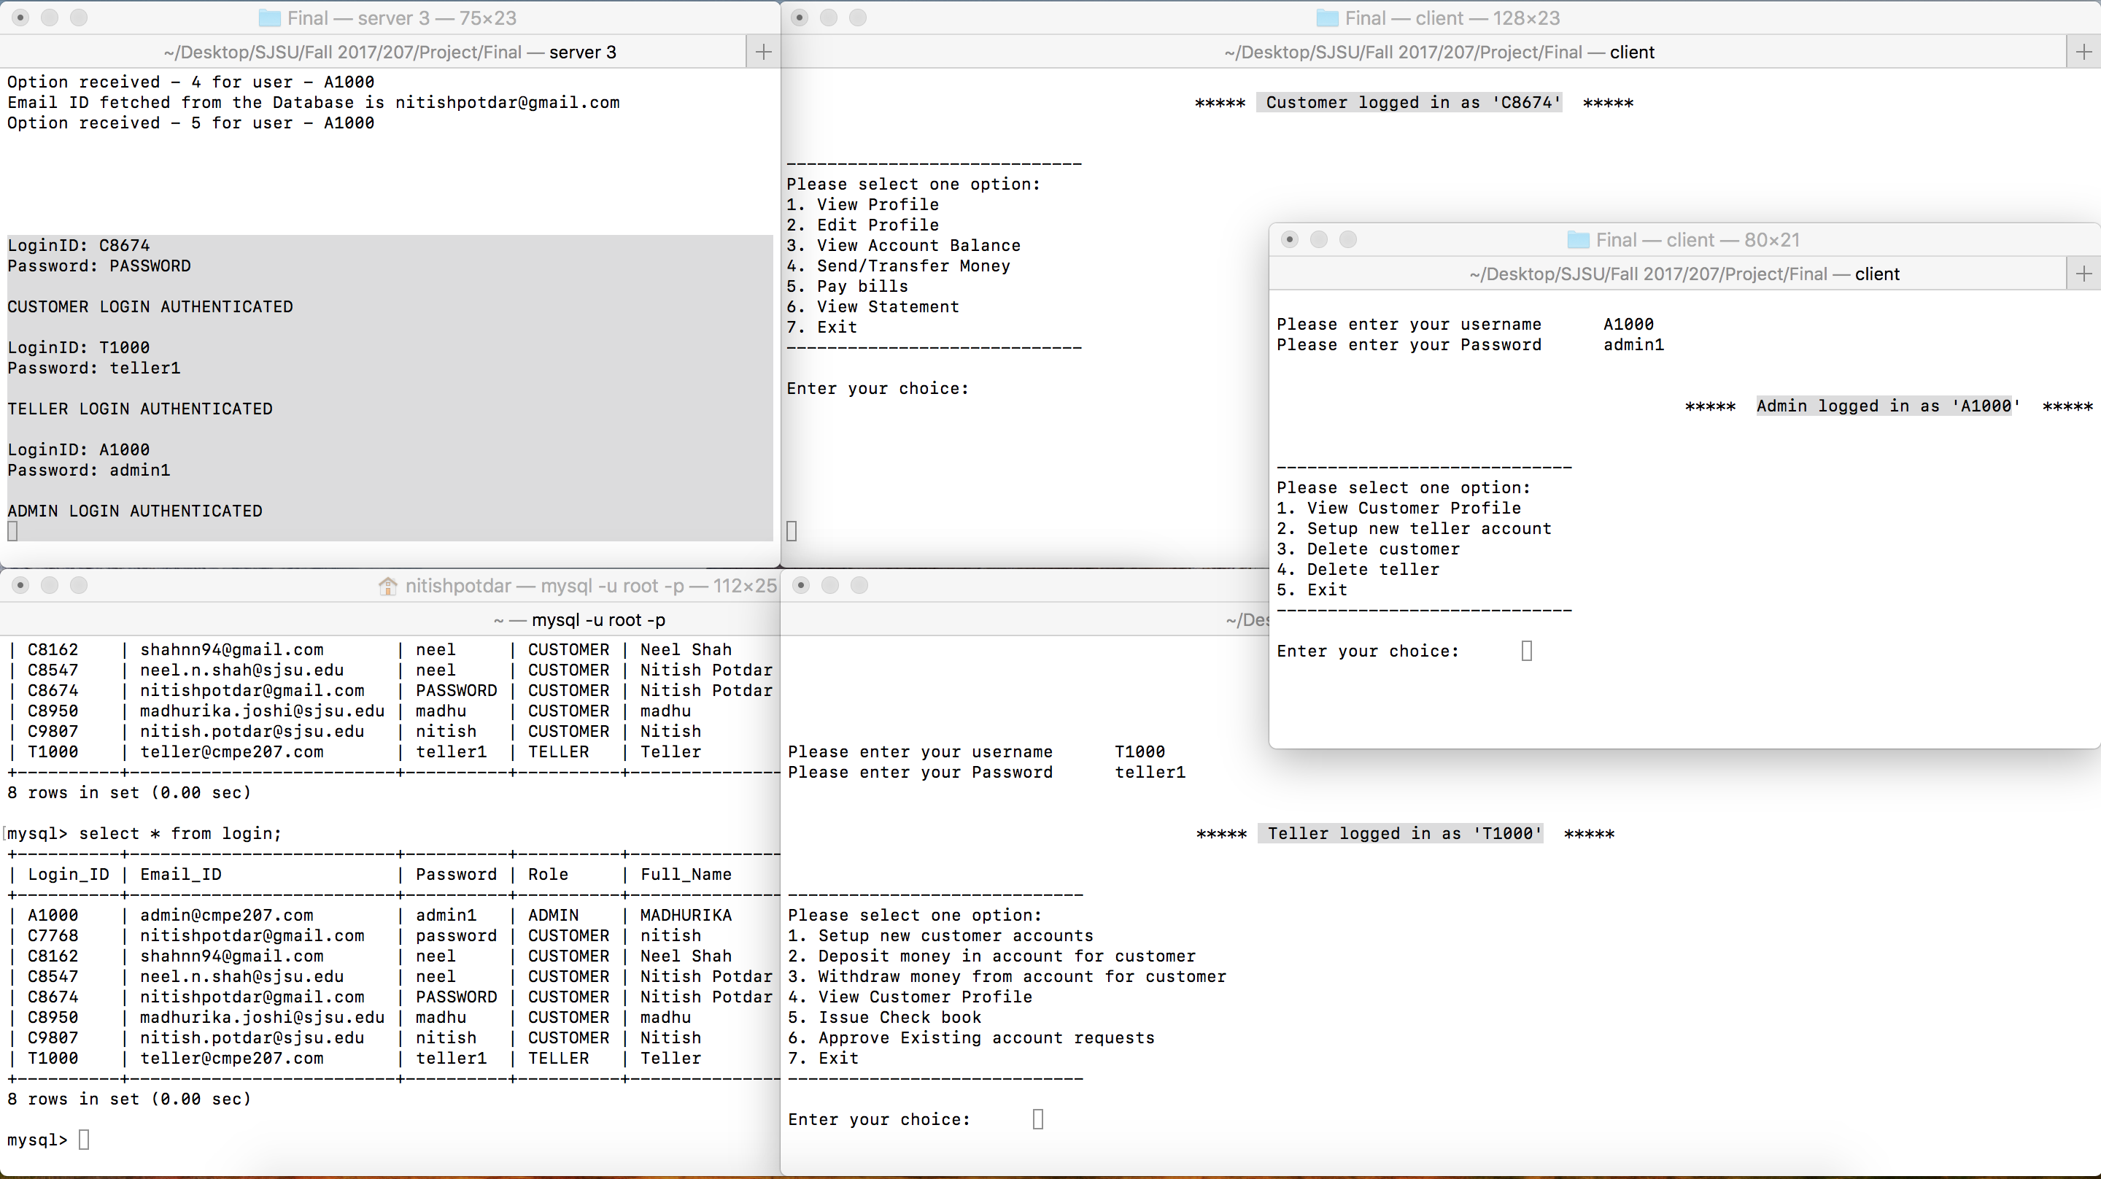

Fig. 1.30 – Multi-threaded server handling multiple client requests